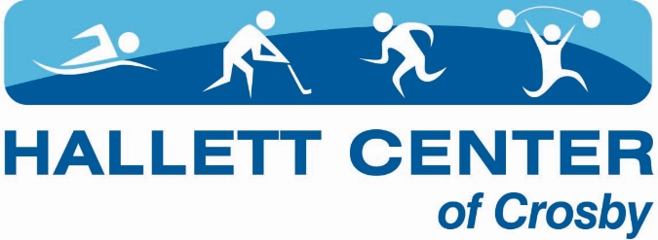

Dear Kidz Kamp Families;
We are looking forward to getting registration going for 2022! We have learned a lot in the last year and have some subtle changes from our experience last year.
Registration: Registration will start on 05/01/2022 for any interested party. All registration will be at the Hallett Center during business hours. Payment & participant paperwork go hand in hand. There is a high demand for this Kidz Kamp and we cannot hold spots for participants. Parents or guardians that complete paperwork & make payment will secure a spot at camp. We will be updating the website and Facebook as to program availability. Participants registered for any session in June will have priority registration for the following month. There is NO part-time registration this year due to weekly registration.
Reservation: There will be no reservations this year. A registration is only complete with completed paperwork and full payment at the time of registration.
Behavior Policy: Our behavior policy has been updated this year. Please review the behavior policy with your camper and attach the signed form with your registration materials. Registration will not be accepted without a signed behavior policy form.
Closure and Quarantine: Once the session has started, if the government orders dictate the closure of Kidz Kamp or your participant needs to quarantine due to risk of exposure; reimbursements, credits or refunds will not be awarded. If there is a confirmed case of COVID-19, the Hallett Center will respond in accordance with the closures and cleaning outlined in the Hallett Center Preparedness Plan including and not limited to closing the facility or programs.
Respiratory Etiquette: Masks are not required this year. Please help educate your participant on covering their mouth if they need to cough or sneeze as well as minimizing touching their eyes, nose and mouth.
Signs and Symptoms: Symptoms of COVID-19 may appear 2-14 days after exposure to the virus. People with these symptoms should stay at home: Cough, shortness of breath or difficulty breathing, fever, chills, muscle pain, sore throat, and/or new loss of taste or smell. This list is not all inclusive. Other less common symptoms have been reported, including gastrointestinal symptoms like nausea, vomiting, or diarrhea. Please notify the us if your child or anyone in the home is experiencing symptoms or have been exposed to a person with COVID-19. Participants are asked to stay at home when they are sick, when household members are sick, when required by a health care provider to isolate or quarantine themselves or a member of their household or awaiting COVID-19 test results.
The Kidz Kamp program will be reviewed by staff weekly. We are hopeful that with everyone’s help, the kids can safely play and interact. Please contact info@hallettcenter.com with any questions or concerns. You can find more information on www.hallettcenter.com under the children’s programs tab over the next couple weeks.
Respectfully,
Katheryn Carpenter
Katheryn Carpenter, General Manager
Hallett Center of Crosby
218-546-2616

