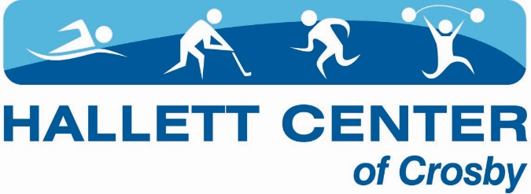

Dear Soccer Families;
We are excited about the opportunity to host another season of soccer. This year, we are beginning to get back to normal but still have a few considerations in regards to COVID-19. We know there will be a lot of questions and we hope to address a few key changes in this letter. The health and safety of all associates and program participants is our highest priority. We are taking our role in mitigating the spread of COVID-19 seriously and our strategies may change if the level of community transmission increases to the point where intervening is warranted. Our policies in regards to the pandemic are living documents and will be updated and communicated to you in writing as the CDC and MDH update their guidelines.
Registration: We do not have a cap on registrations this year! You can turn in your paperwork at the Hallett Center front desk starting August 16th. You will be required to turn in a check or pay with card at that time to hold your spot.
Closure and Quarantine: Once the season has started, if the government orders dictate the closure of youth sports or your participant needs to quarantine due to risk of exposure; reimbursements, credits or refunds will not be awarded. If there is a confirmed case of COVID-19, the Hallett Center will respond in accordance to the closures and cleaning outlined in the Hallett Center of Crosby Preparedness Plan including and not limited to closing the facility or programs.
Hand Washing and Screening: Each participant is required to wash or sanitize their hands before starting practice and stay home if they or a household member have any symptoms of COVID-19. If a child develops symptoms at practice, parents and guardians will be contacted to pick up the child immediately.
Social Distancing: No more than 25 people are allowed on the playing field. Participants will be asked to maintain 6 feet of separation. Personal items are to be kept separated and are not to be shared. Equipment will be sanitize throughout each practice.
Respiratory Etiquette: Masks are not required and are encouraged. Please help educate your participant on covering their mouth if they need to cough or sneeze as well as minimizing touching their eyes, nose and mouth.
Signs and Symptoms: Symptoms of COVID-19 may appear 2-14 days after exposure to the virus. People with these symptoms should stay at home: Cough, Shortness of breath or difficulty breathing, Fever, Chills, Muscle pain, Sore throat, and/or New loss of taste or smell. This list is not all inclusive. Other less common symptoms have been reported, including gastrointestinal symptoms like nausea, vomiting, or diarrhea. Please notify the staff if your child or anyone in the home is experiencing symptoms or have been exposed to a person with COVID-19. Participants are asked to stay at home when they are sick, when household members are sick, or when required by a health care provider to isolate or quarantine themselves or a member of their household.
You are welcomed to spectate, however please remain distanced. In the event that we have an indoor practice, we ask that you be mindful of distancing and masking practices while in the arena, or choose not to spectate that day.
Please contact info@hallettcenter.com with any questions or concerns. You can find more information on www.hallettcenter.com under the children’s programs tab over the next couple weeks.
Respectfully,
Katheryn Carpenter
Program Manager

